Phase-4
Develop a Web Application using
frontend stack
Project :-Kitchen Story
(Application Screenshots)

Version History
Author | K.Swathi
Purpose | Screenshots of the Application
Date | /12/2021
version | 1.0

1

Table of Content:
User Experience: ......................................................................................................................................... 3
Main Page: ........................................................................................................................................................... 3
User Sign Up: ........................................................................................................................................................ 4
User Sign In: ......................................................................................................................................................... 5
Invalid Login: .................................................................................................................................................... 5
User Main Page: ................................................................................................................................................... 6
View Cart and Place Order: .................................................................................................................................. 7
Order Detail: ......................................................................................................................................................... 8
Admin User Experience: ........................................................................................................................................... 9
Admin Login: ...................................................................................................................................................... 10
Invalid Admin Login: ....................................................................................................................................... 11
Admin Main Page: .................................................................................................................................................. 12
View Users:......................................................................................................................................................... 13
Edit User Details: ............................................................................................................................................ 14
Add New User: ................................................................................................................................................... 15
View Products: ................................................................................................................................................... 16
Edit Product Details: ................................................................................................................................... 17
Add New Product: .............................................................................................................................................. 18
Purchase Report: ................................................................................................................................................ 19
View Purchase Report: ................................................................................................................................... 20
2

Admin Login
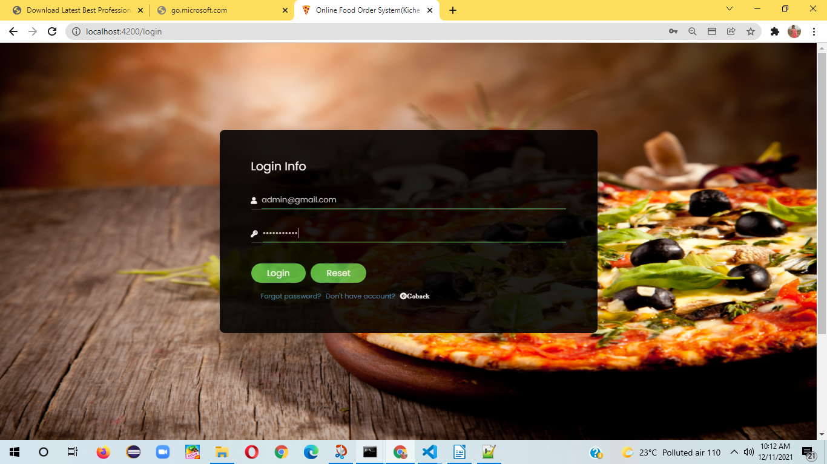
After Logon admin home will display orders list:
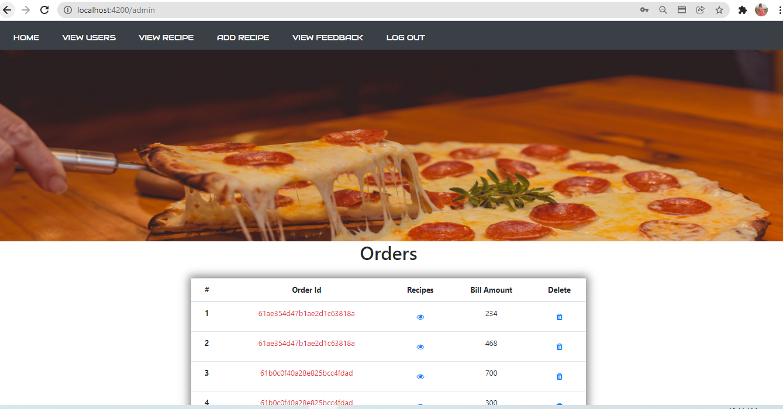
3
Admin Home:
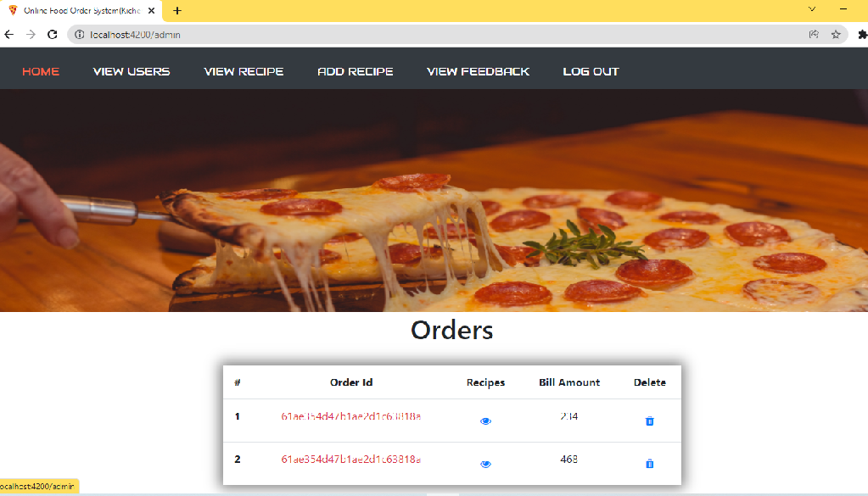
view users
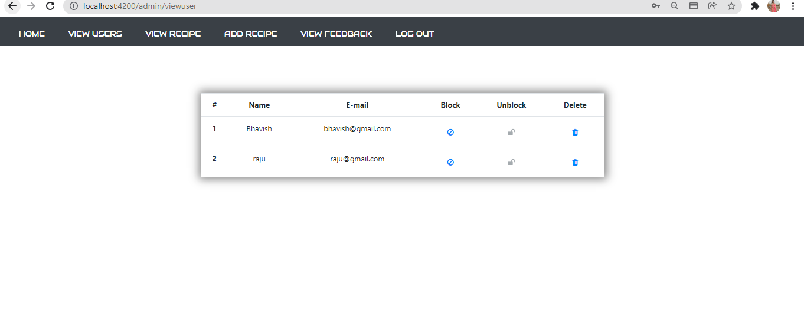

4
Add Recipe
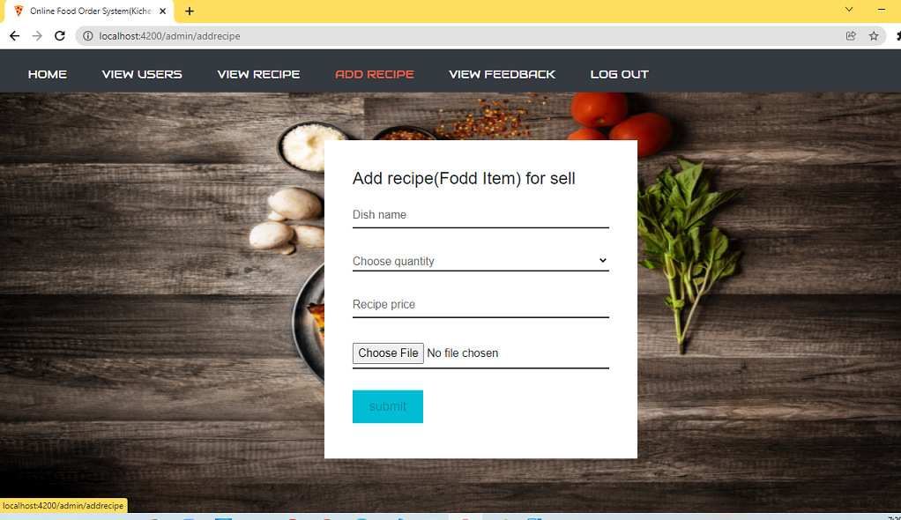
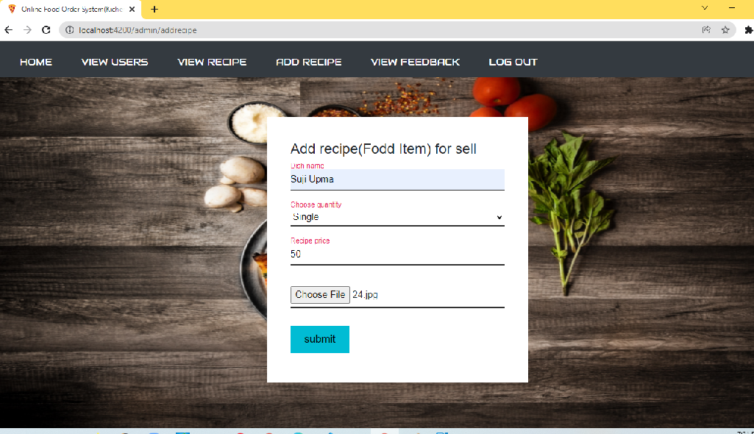

5
view recipe
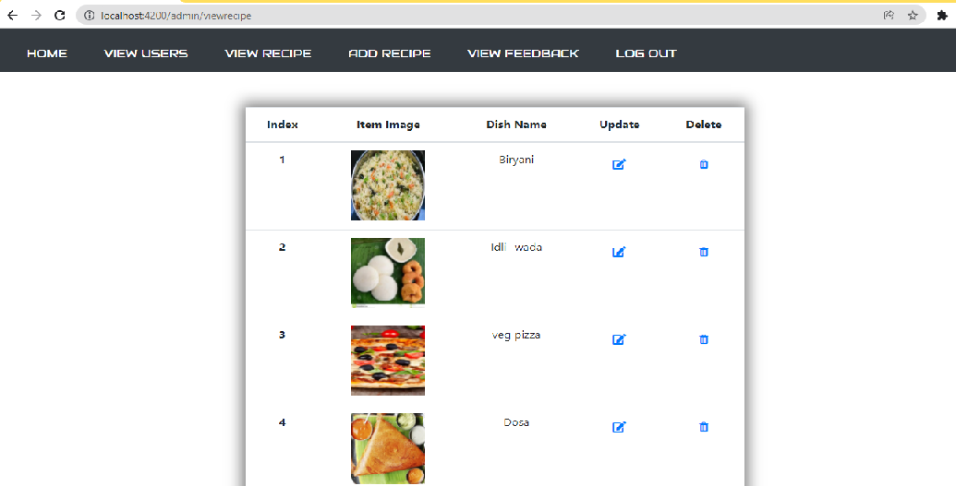

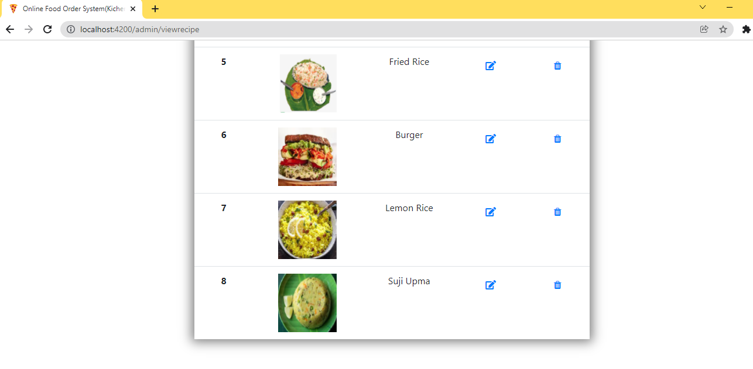

View Feed back
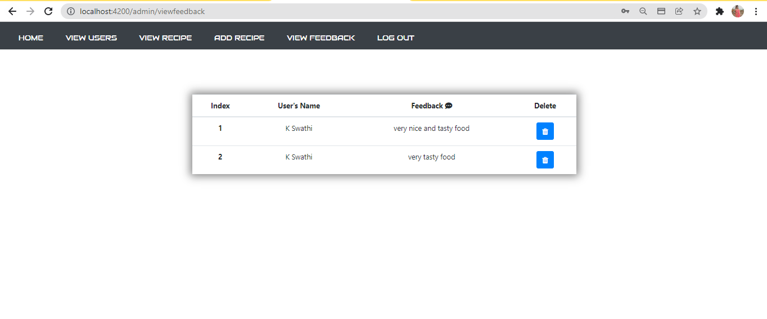

User Flows:
1)Web home page
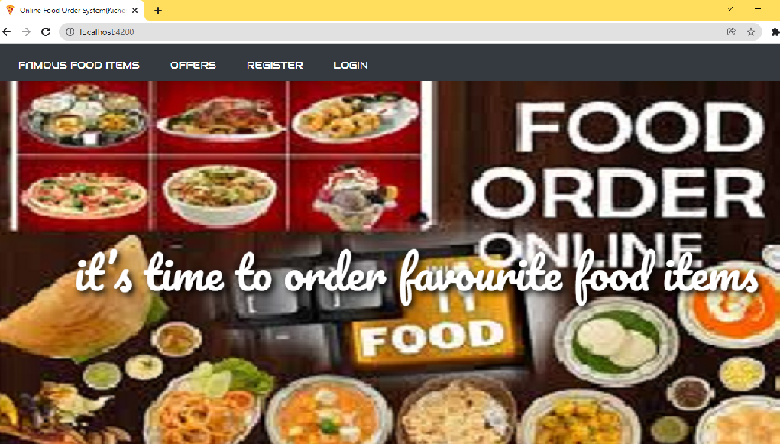
2) View famous food items
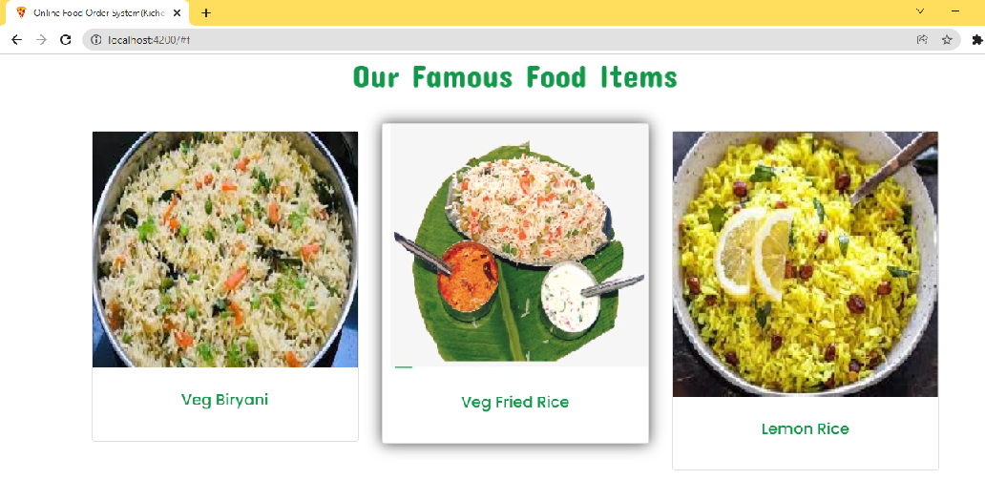

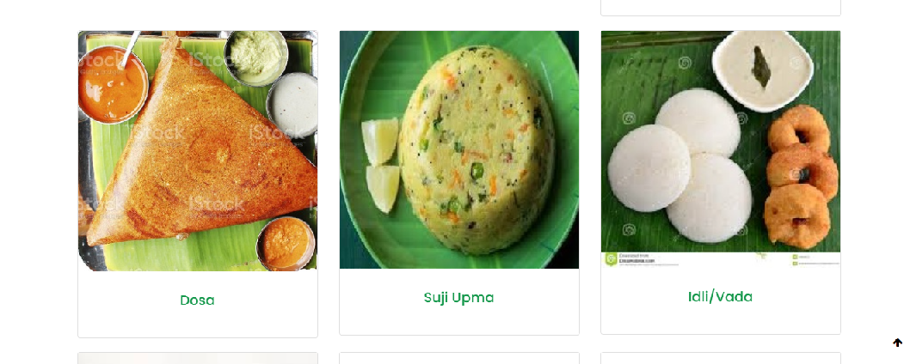

Check for offers
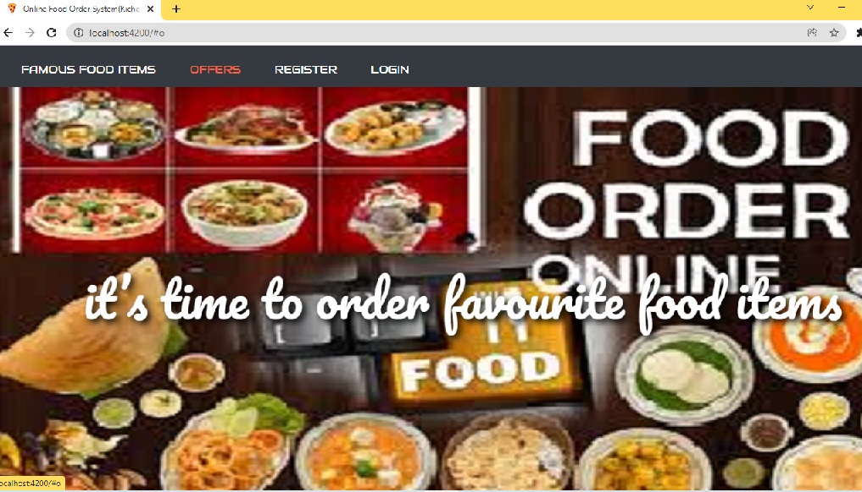

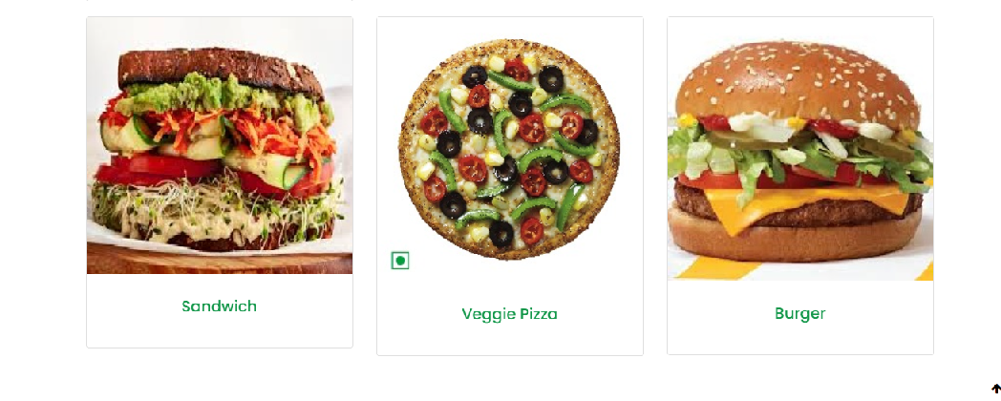
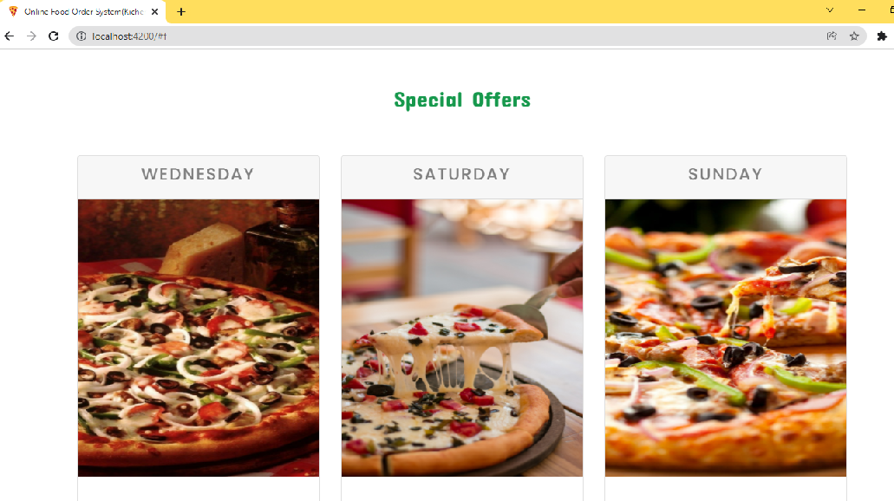
User Registration (click on register)

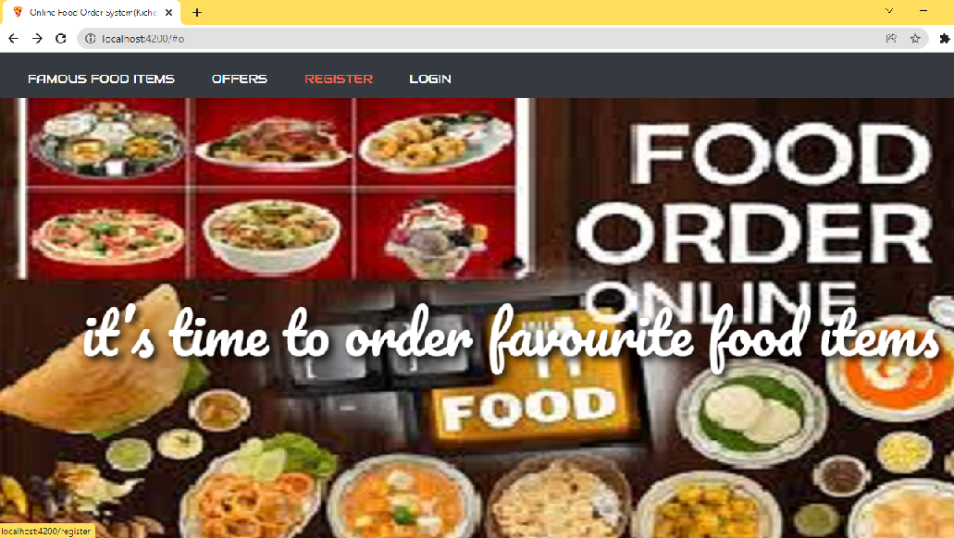

Provide User details for Registration
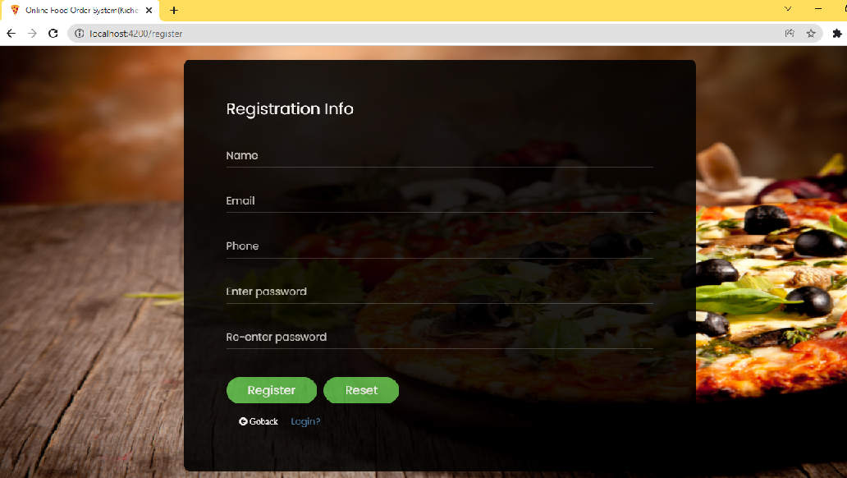
Validating user form:

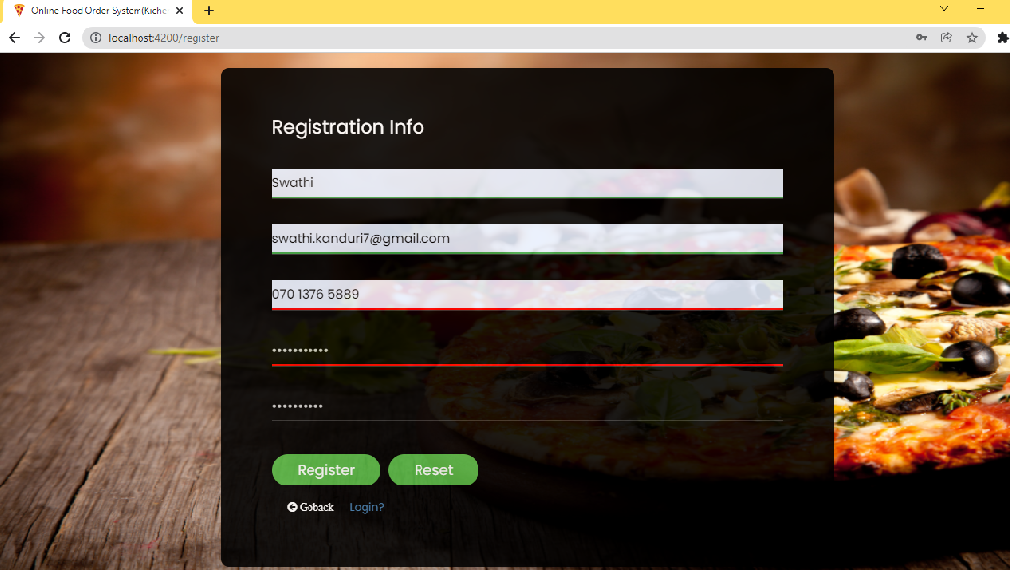

Ater Successful Registration it will redirect to login page

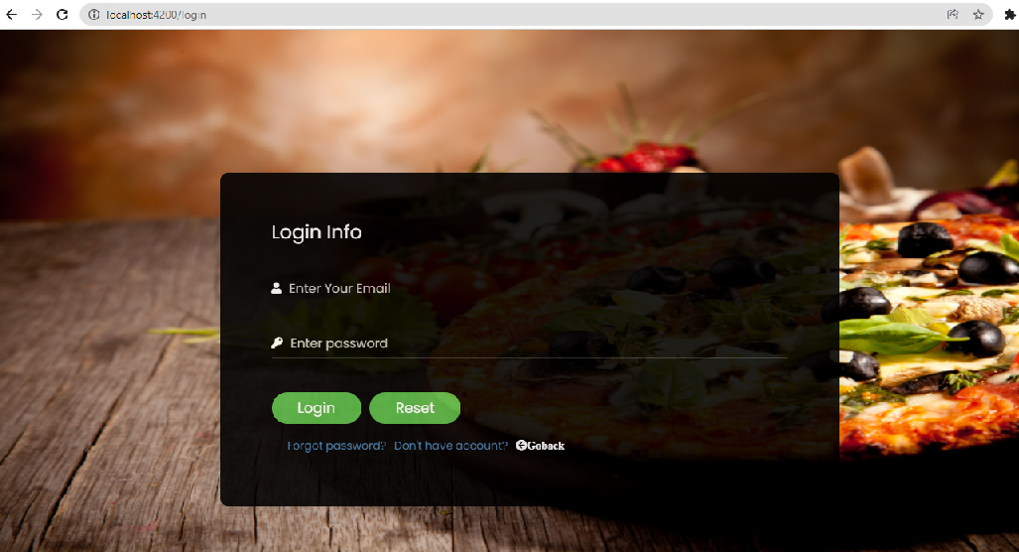
User Login:-
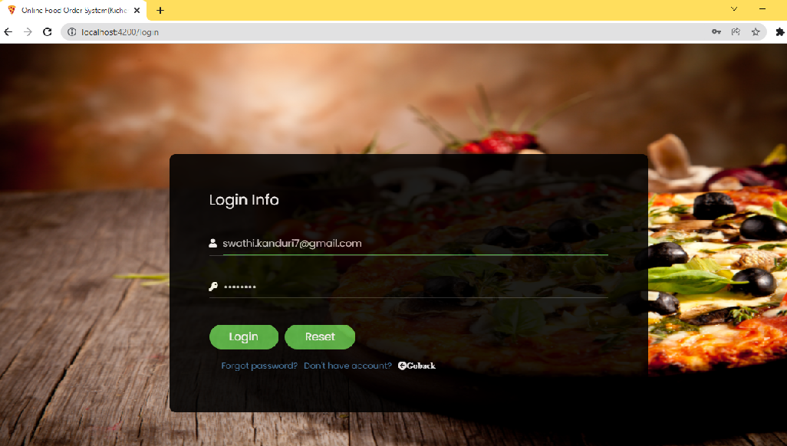

User Home
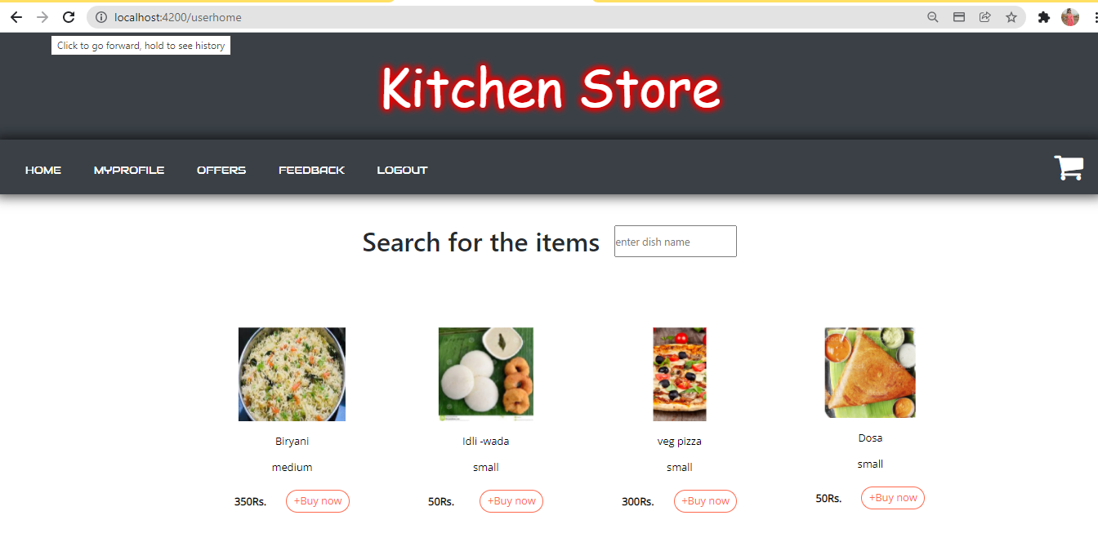

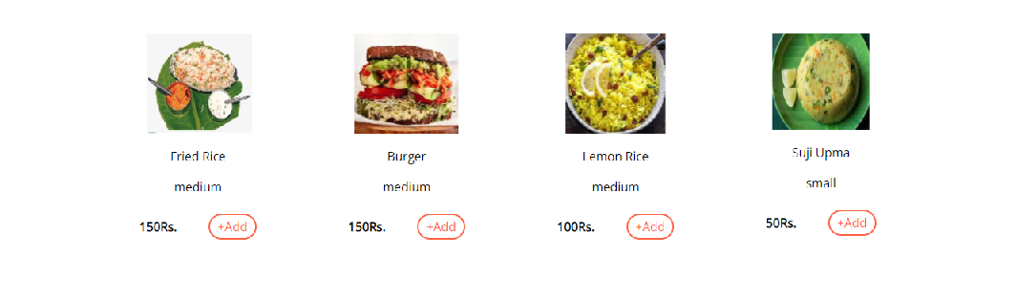

Search for the items:
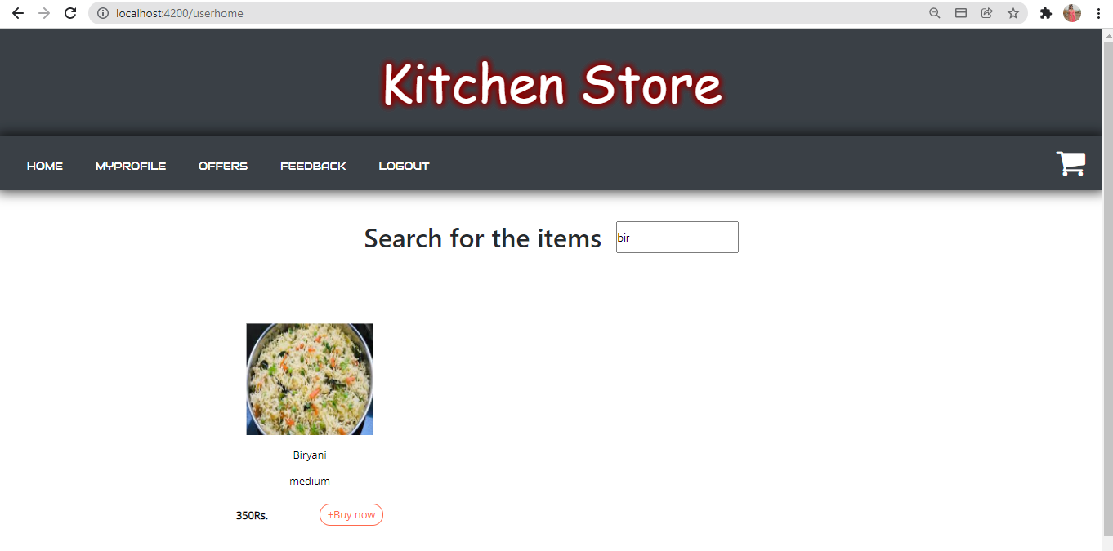

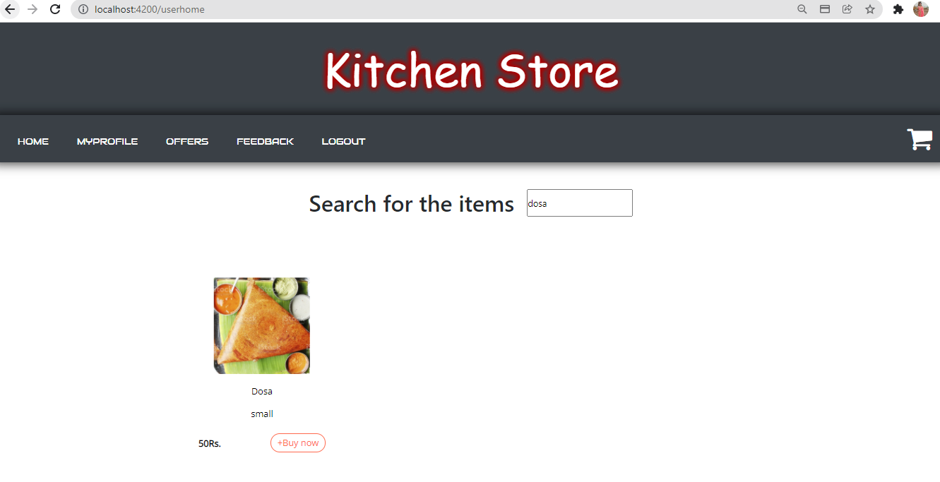

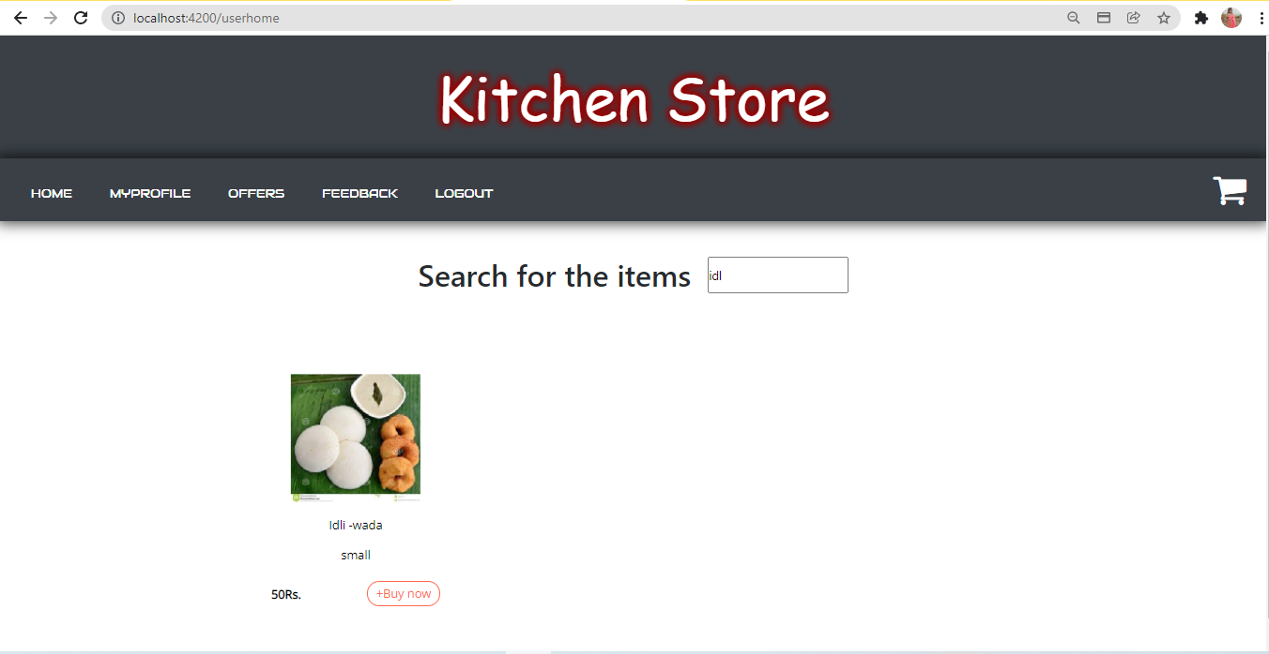
Buy Now:
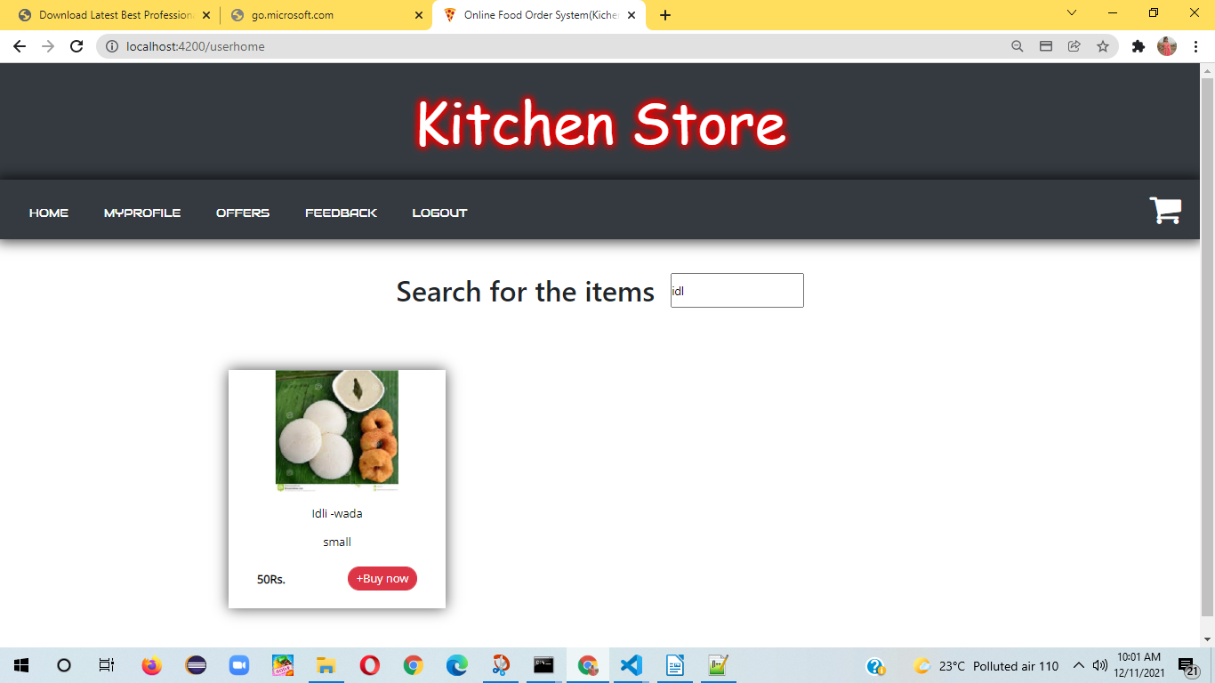

Go to Cart to check out:
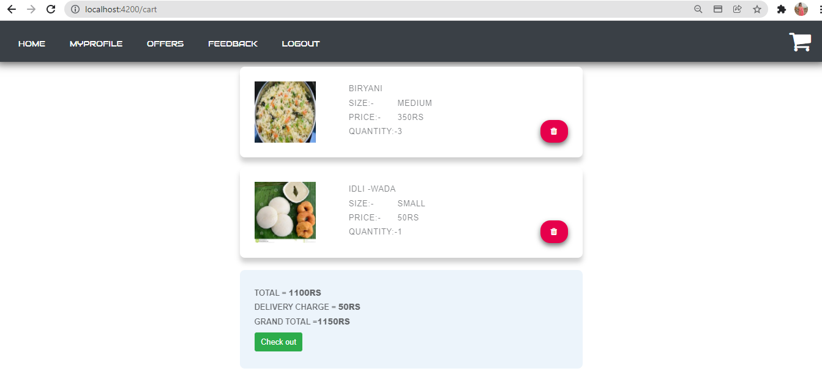

Click on check out for payment:
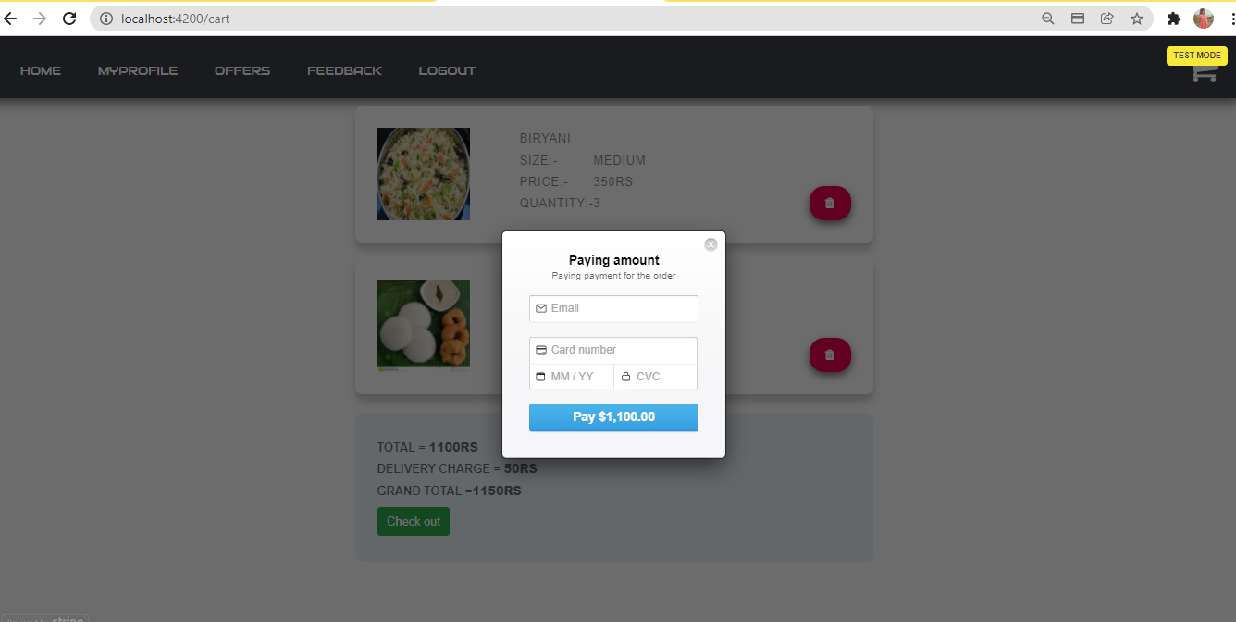

Provide the details (debit/credit card)
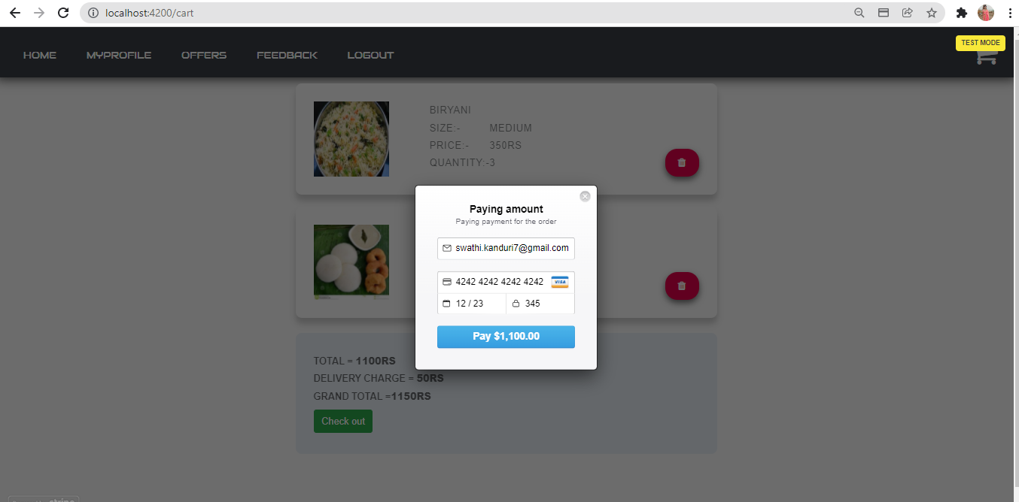

payment successful:-

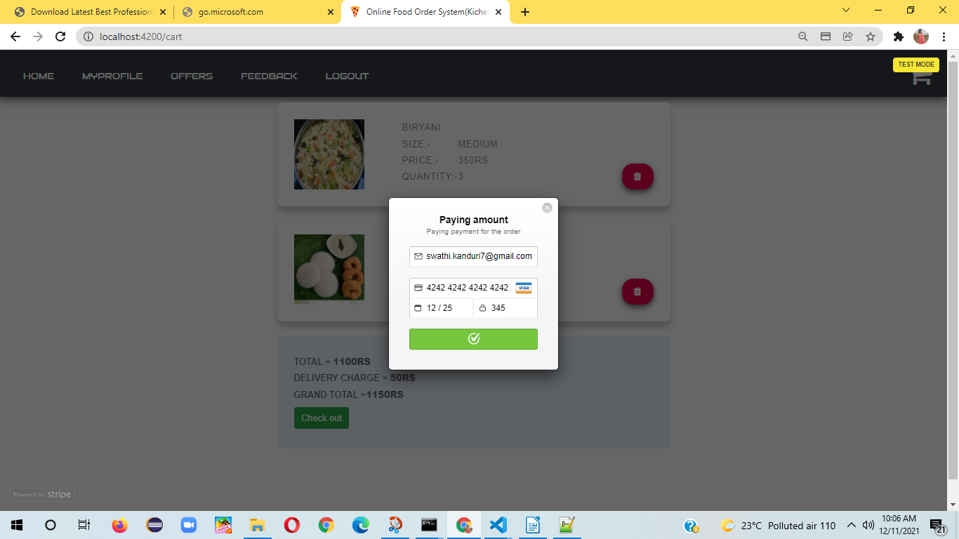

Placed order successfully Confirmation display:

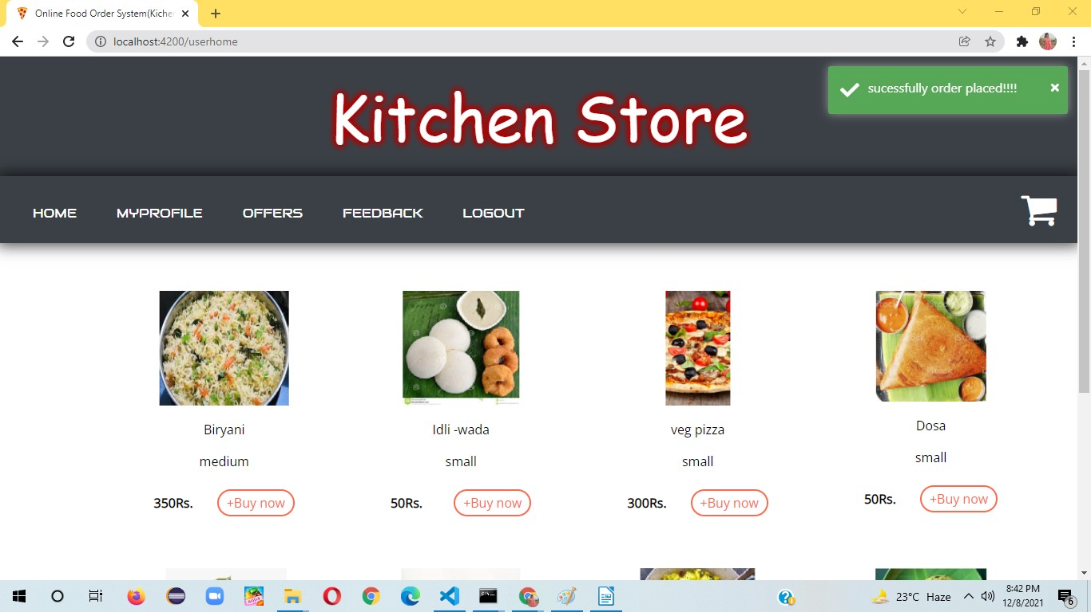

User Profile Settings:
Click on my profile
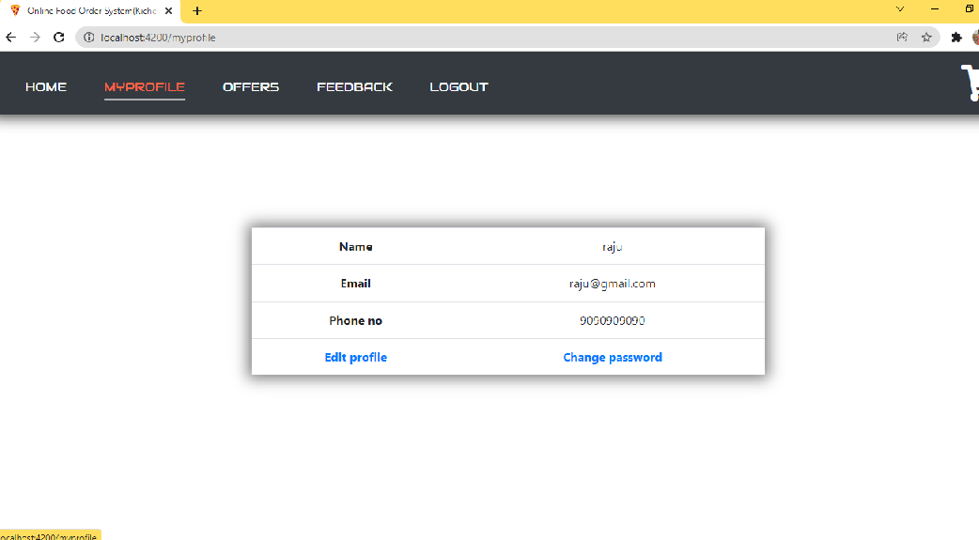

click on edit profile

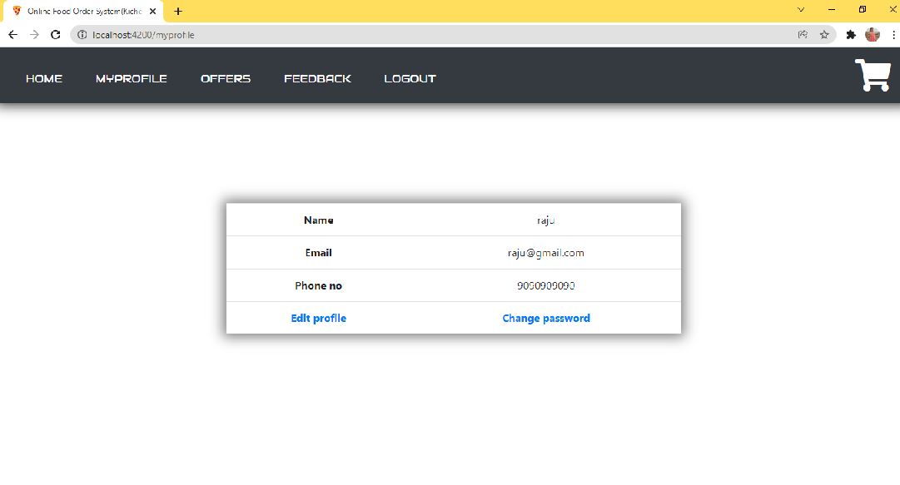
Edit profile
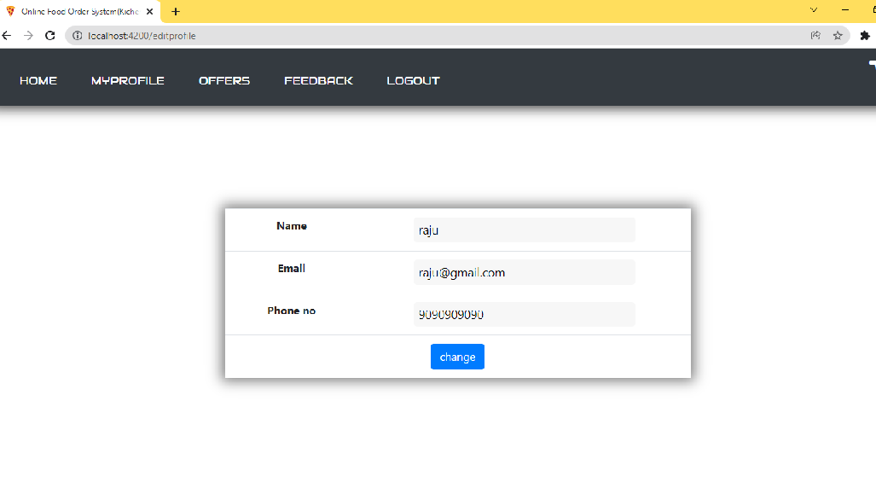
To change password
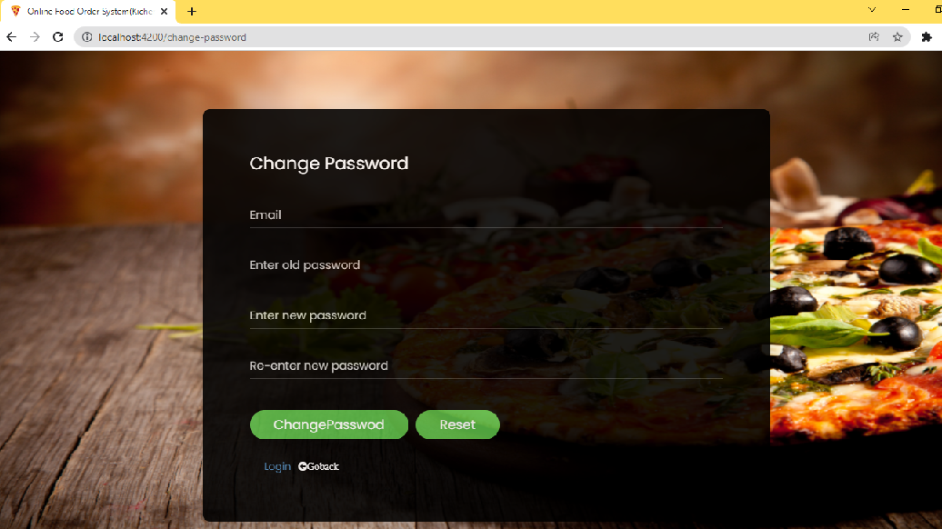

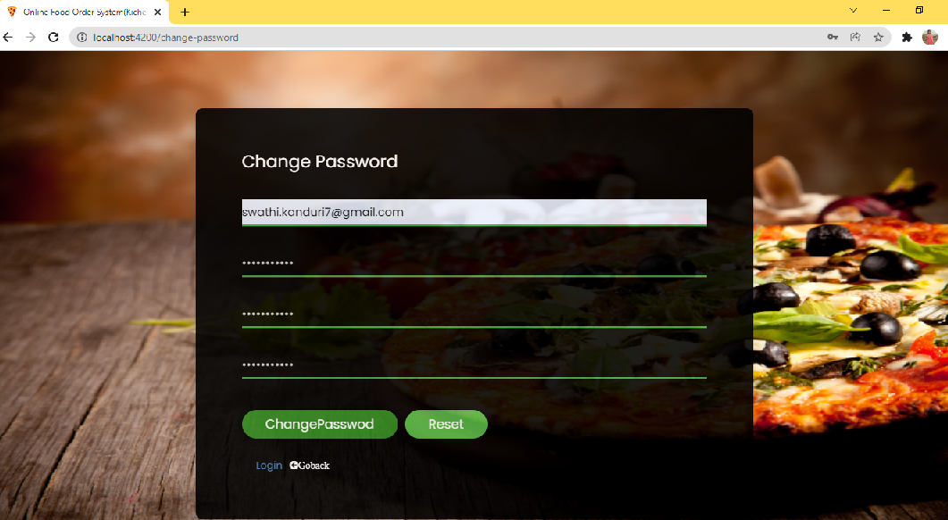

forgot password
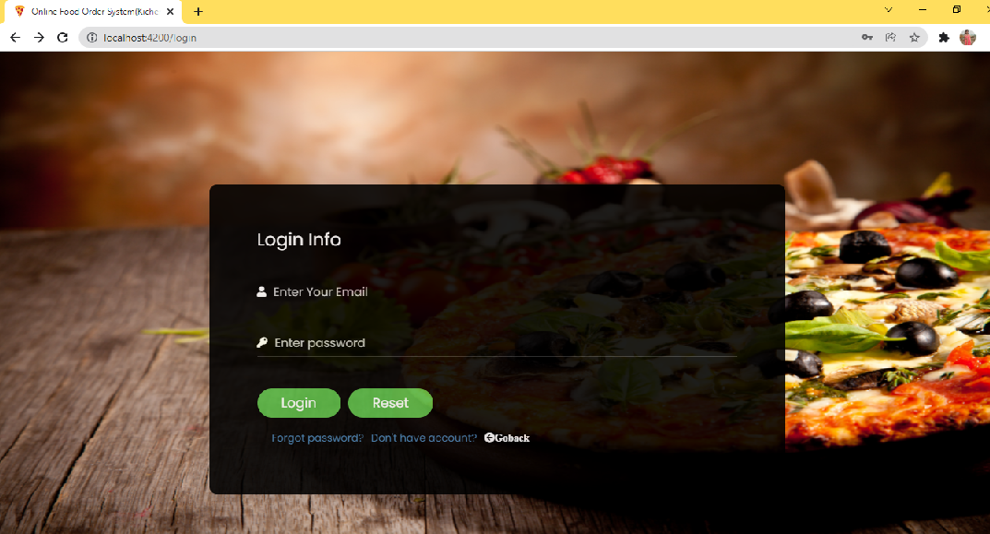

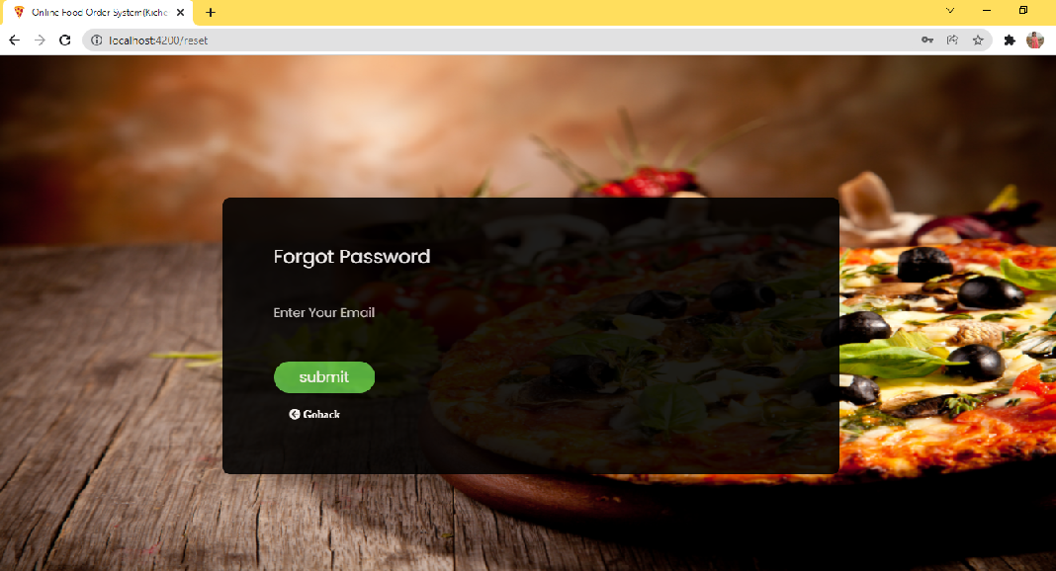
To provide Feedback
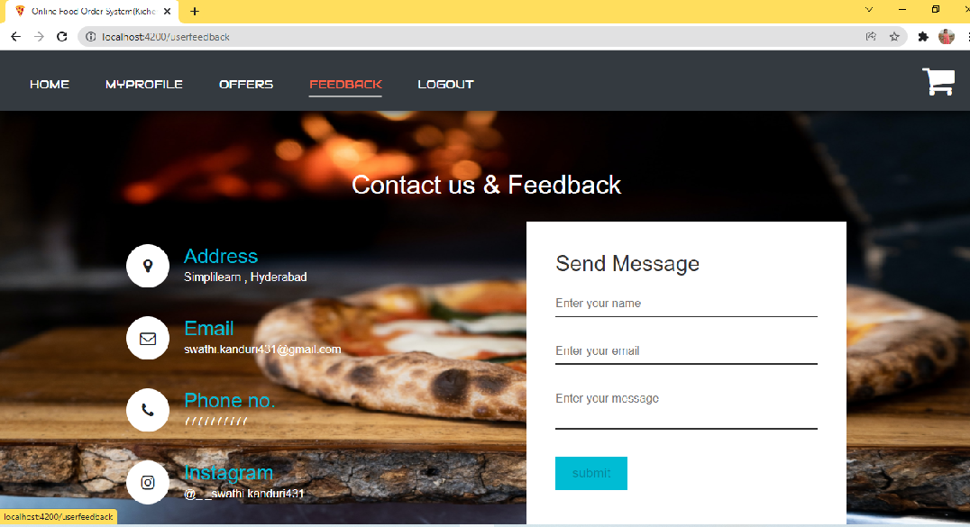

Contact and feedback form
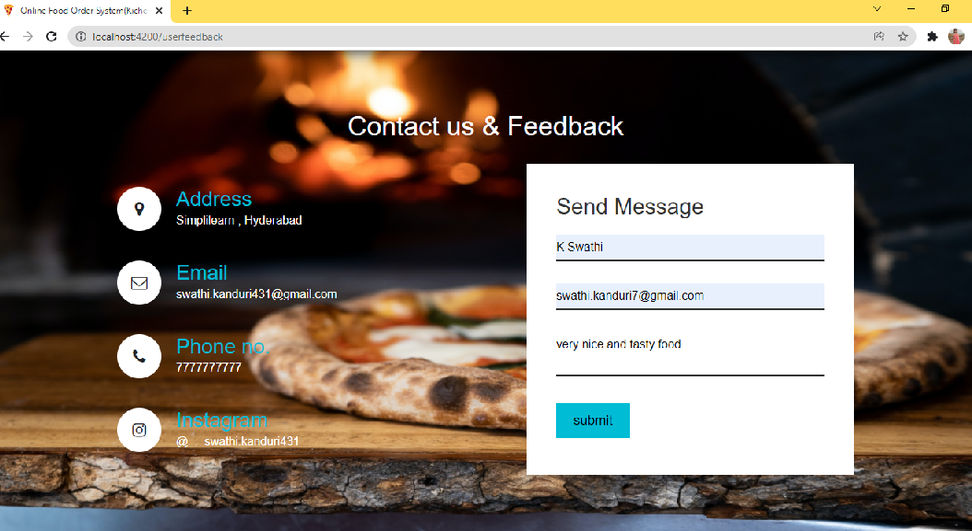
After adding feedback it will redirect to user home pabe
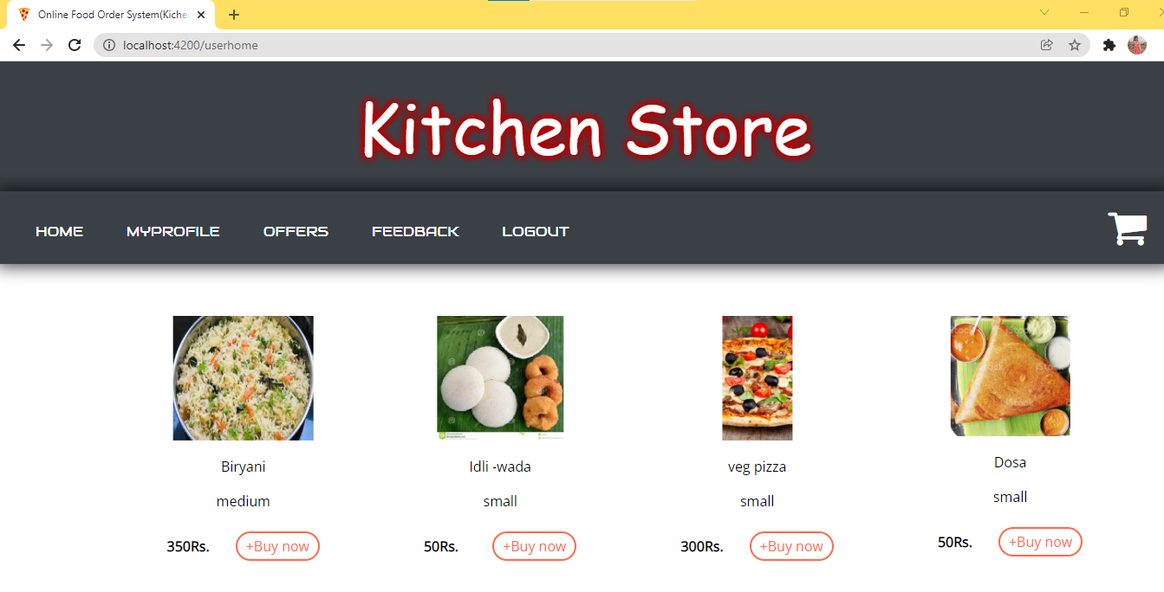

Logout


